Data Preparation Documentation

Dataset Loading and Initial Exploration
The dataset was loaded using the panda’s library. An initial exploration was conducted to understand the data structure, variable types, and data quality. This included examining the first few records, checking data types, and identifying missing values.
Key steps included:
- Loading the dataset from a CSV file
- Inspecting column data types using df.info()
- Checking for missing values using df.isnull().sum()

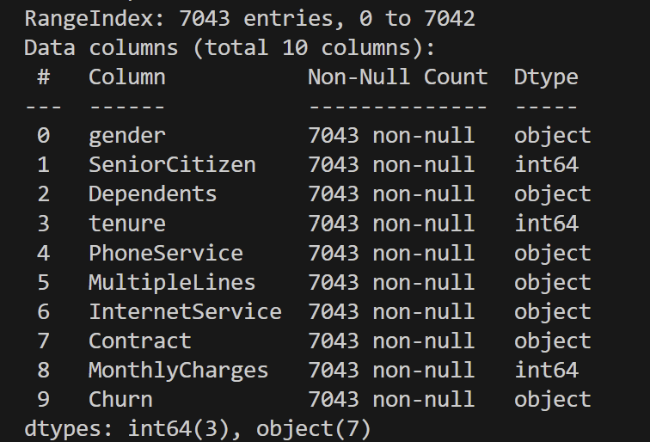
This ensured that the dataset was suitable for further preprocessing and analysis.

Handling Categorical Variables
The dataset contained both binary and multi-class categorical variables, which required appropriate encoding before analysis.
Binary Categorical Encoding
Binary categorical variables were transformed using Label Encoding, converting textual categories into numerical form (0 and 1). The following variables were encoded:
- gender
- Dependents
- PhoneService
- MultipleLines
- Churn (target variable)
This transformation enabled machine learning algorithms to process these variables efficiently.
Multi-Class Categorical Encoding
Variables with more than two categories were encoded using One-Hot Encoding via pd.get_dummies(), with drop_first=True to avoid multicollinearity. The encoded variables included:
- InternetService
- Contract
This approach converted each category into a binary indicator variable, allowing the model to distinguish between different service and contract types.

Feature-Target Separation and Train-Test Split
The dataset was divided into:
- Features (X): All variables except the target
- Target variable(y): Customer churn indicator (‘Churn’)
An 80/20 train-test split was applied using stratified sampling to preserve the original churn distribution across both datasets. This step ensures fairness and consistency when comparing model behaviour across subsets.

Feature Scaling
Before clustering, numerical features were standardised using StandardScaler, which transforms features to have:
Mean = 0
Standard deviation = 1
Feature scaling is essential for distance-based algorithms such as K-Means, as it prevents variables with larger magnitudes from disproportionately influencing cluster formation.

Output of Pre-processed Data
The resulting dataset:
- Contains no raw categorical variables
- Is fully numerical
- Is suitable for machine learning and clustering analysis
This completes the data preparation phase and ensures analytical readiness.

